Hugh Brennan
CITP 190
Project 13
April 27, 2012

The Applet Viewer Window:
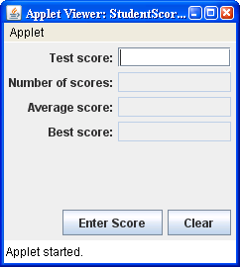

The applet after the first three
scores have been entered:

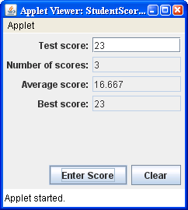

The applet after the last four
scores have been entered:

